
University of Iowa Press
119 West Park Road
100 Kuhl House
Iowa City, Iowa 52242-1000

ART PROGRAM GUIDELINES Updated 5.29.25

IMPORANT THINGS TO NOTE

• All art program inclusions (artwork, graphs, charts, photographs, etc.) must adhere to what is agreed upon in the signed author contract and must meet the press’s print-quality standards. The press reviews and must approve all art program submissions. All required permissions must be secured by the author and shared with the acquisitions department (see Author Checklist document for full requirements and process).

• The following guidelines reference “figure” file requirements and “image” file requirements. The press defines “figures” as maps, charts, graphs, and so on; data-driven art. The press defines “images” as artwork, photographs, images, screen grabs, and so on; image-focused art.
Page 5 of these guidelines offers information on how to assess file size and resolution.

• The press does not wish to receive original art shipped to the press. In certain cases exceptions can be made, but these are rare. The press prefers to work exclusively with digital files.

• The press strongly recommends that authors work with professional graphic arts services if they need images scanned or that they work directly with professional businesses/organizations that already have print-quality scans of the art (libraries, archives, museums, estates, etc.).

Image File Requirements (photographs, artwork, posters, screen grabs, etc.)
- Please send us original images. DO NOT adjust, upsample, or convert your images. We have internal processes as well as professional companies that know what our printers require.
- Image size should be around 5 x 7 inches
- Image resolution for grayscale art must be a minimum of 300 pixels per inch (ppi); image resolution for color and/or bitonal art should be 600 to 1,200 ppi
- Images should be saved as JPG, TIF, or EPS file formats (we do not accept GIF, PNG, or BMP)
- Each image needs to be saved using the following naming system that includes the author’s last name and numbered figures as they appear in the manuscript; all must align with image callouts in the manuscript, captions, and alt text. For example: Figure 1 Smith.jpg, Figure 2 Smith.jpg, Figure 3 Smith.jpg

Specific Screen Grab Requirements
- If an image can only be found online (i.e., a frame from a GIF or a YouTube video), we accept screen grabs if they are within our print-quality standards
- The press recommends software such as Final Cut, Capture Me, or DVD Snap to capture video stills
- Screen grabs should be at least 3 inches or 900 pixels wide at 300 ppi
- Higher display resolution on your monitor will assist with capturing a higher-quality screen grab. For example, if you capture a 1680 x 1050 screen grab you will get a 5MB RGB file, for reproduction at 5.6 x 3.5 inches

Figure File Requirements (graphs, maps, charts, tables, etc.)
- The press prefers figures such as graphs, maps, charts, and so on be created in Adobe Illustrator; if you use another program, save files as EPS or provide an EPS version in addition to the application version of the file
- When submitting figures, please include all fonts and all linked graphics and/or data files
- For tables created in Word, please keep saved as separate files and do not embed in manuscript

Submitting Art Program Files
- Do not embed any file, figure, or image within the manuscript document
- All art program files are to be saved separately using the aforementioned naming system
- Place figure callouts in the manuscript; the manuscript (along with captions and alt text) should be emailed to your acquisitions editor and not through the art program process
- If any art program submission requires specific instructions (cropping, placement, size on page, etc.), please share those instructions with your acquisitions editor via email
- Submit all art program files using platforms such as Dropbox or WeTransfer, and send a confirmation email to your acquisitions editor

Captions and Alt Text
- Create separate captions and alt text Word documents, organized by figure number; see Author Checklist document for further information/instructions
Note: Captions and alt text documents should be emailed with the final manuscript to your acquisitions editor
- For captions, in addition to a brief description of the image or figure, include source and credit line information
- Alt text differs from the caption; this copy will be read aloud for readers of the eBook
- For further information about alt text, please see the Chicago Manual of Style: https://www.chicagomanualofstyle.org/book/ed18/part1/ch03/psec028.html
- Alt text per image or figure should be no more than 150 characters (with spaces); you can check this count by selecting Word Count in Word and looking for Characters (with spaces)
- Alt text should avoid unnecessary use of descriptors such as colors and don’t make assumptions about the imagery if not identified in the caption. For instance, say “two people” instead of “a man and a woman” to avoid gendered language; instead of saying “a blue and white striped car” note a “striped car”
- An exception to the 150 character (with spaces) alt text length is if there is text to be read within the figure or image, such as a sign or an advertisement—include all that text in the alt text description
- For figures, we offer additional suggestions when writing alt text:
• Provide a succinct overall description of the figure, including the type of graphic (map, chart, table, etc.), the main elements, and a summary of the contents
• Describe the overall trend in bar charts
• Focus on the data rather than the appearance of the figure
• For graphs, describe the axes and key coordinates or elements and provide the data in a bulleted list
• For scatter plots, focus on the main trend of the data if the location of specific data is not required
• Spell out units in full (for example, kilometers rather than km) to aid comprehension
• Order the information logically (for example, for pie charts list the numbers from largest to smallest)
• If the image is for an educational text, ensure the terminology used is appropriate to the learning level, matches the vocabulary in the surrounding text, and does not introduce terms or concepts that haven’t been addressed yet
• Provide the axis and any other labels in the figure
• A long description should be provided in addition to the 150-character alt text when it is not possible to describe the contents of the figure within the 150-character limit of the alt text

Example
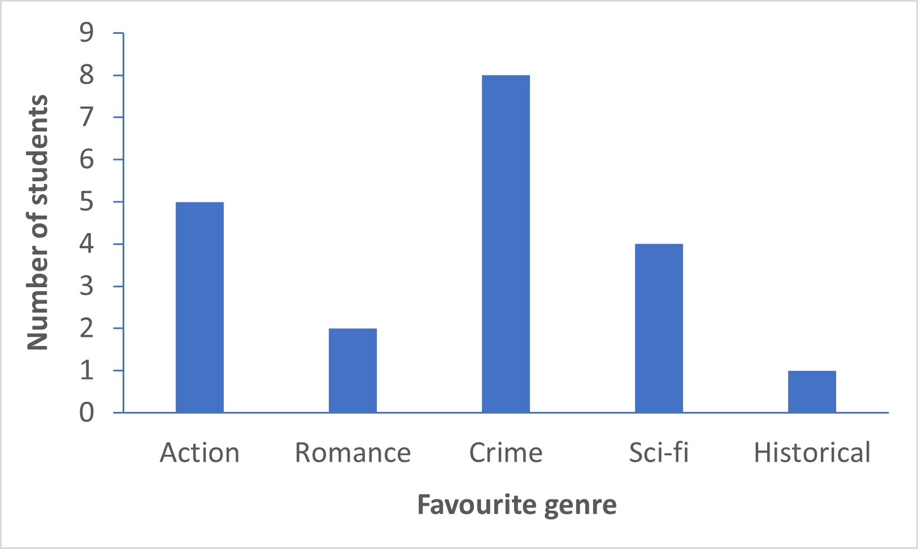

Caption: Types of novels preferred by students in Class 9B.

Alt text: A bar chart shows five genres of novel and the number of students who prefer reading each genre. The genres are action, romance, crime, sci-fi, and historical. Crime novels are the most popular and historical novels the least.

Long description: The y-axis shows the number of students, ranging from 0 to 9. The x-axis shows the favorite genre: Action: 5 students; Romance: 2 students; Sci-fi: 4 students; Historical: 1 student

